

“A CASE STUDY ON CUSTOMER RETENTION IN E-COMMERCE SECTOR”

Submitted by:

**RAHUL AHUJA**

**INTRODUCTION**

* Business Problem

Today the world outside is very competitive and so as the online shopping domain. There is a huge competition and the companies are finding it difficult to retain the customer.

* Conceptual Background of the Domain Problem

Customer satisfaction has emerged as one of the most important factors that guarantee the success of online store; it has been posited as a key stimulant of purchase, repurchase intentions and customer loyalty. A comprehensive review of the literature, theories and models have been carried out to propose the models for customer activation and customer retention. Five major factors that contributed to the success of an e-commerce store have been identified as: service quality, system quality, information quality, trust and net benefit. The research furthermore investigated the factors that influence the online customers repeat purchase intention. The combination of both utilitarian value and hedonistic values are needed to affect the repeat purchase intention (loyalty) positively. The data is collected from the Indian online shoppers. Results indicate the e-retail success factors, which are very much critical for customer satisfaction. So with the study of this data and analytics we need to find out the reason for then customer churn and what companies need to do to retain them.

* Motivation for the Problem Undertaken

The Motive behind doing this study and analysis is:

* To understand the customer behavior that helps companies to retain them.
* Help companies to more alert and competitive.

**Analytical Problem Framing**

* Mathematical/ Analytical Modeling of the Problem

The paper made exploratory research on the need, Problems, influencing factors and future of online shopping. This study based on the comprehensive review of the literature, theories and models have been carried out to propose the models for customer activation and customer retention. Five major factors that contributed to the success of an e-commerce store have been identified as: service quality, system quality, information quality, trust and net benefit. The research furthermore investigated the factors that influence the online customers repeat purchase intention.

* Data Sources and their formats

The Data has been collected from the customers and the entire data has been clubbed in excel for further analysis. The Data contains 269 rows and the 71 columns which contain the personal information of the customers, their views which has been collected using Likert scale technique and questionnaire method.

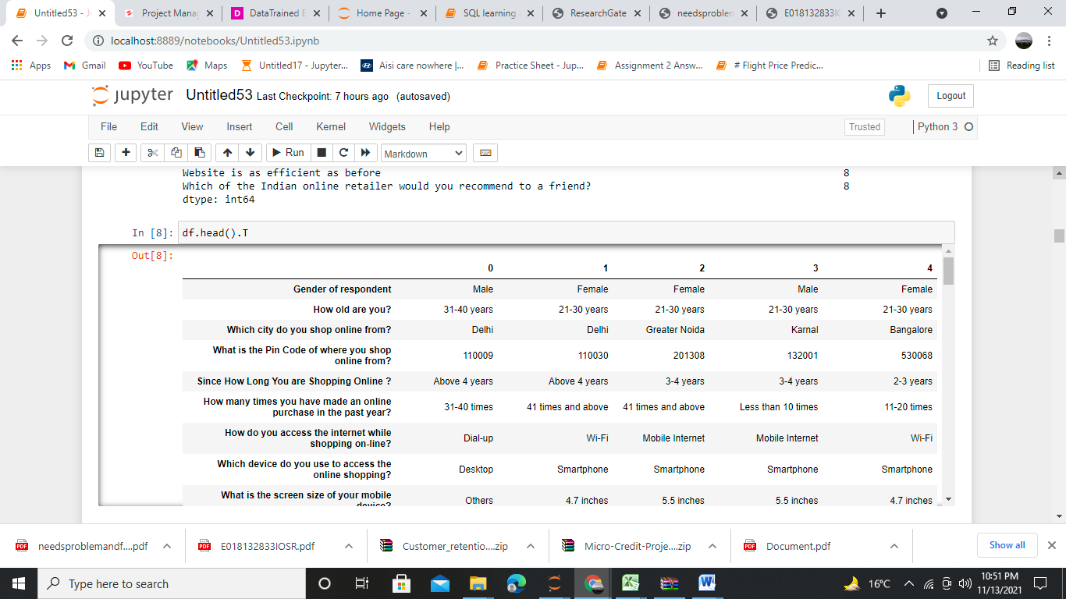

* Data Pre-processing Done

Below are the steps taking for pre-processing and cleaning the data for the  
 analysis.

* Check the data for the null value. No Null Value found.
* Since the data is in the object form so no outliers and skewness found.
* Rectified the string data for visualization.
* Used Label Encoder for converting the object data into float for further analysis.
* Used Min-Max scalar for standardization of the data
* Used PCA for the combining the data which have multi co-linearity.
* Data Inputs- Logic- Output Relationships

The data has been categorized into two and that has been given x and y

y data contains the last columns (Which of the Indian online retailer would you recommend to a friend?”) considering that a loyal customer is the one which can bring or refer the new customers. The purpose is to check this only whether under which condition the customer will remain loyal and not

x data contains the complete data except the last column which will help to predict the customer loyalty

**Model/s Development and Evaluation**

* Identification of possible problem-solving approaches (methods)

Visualizations

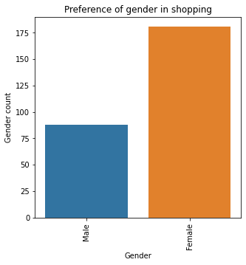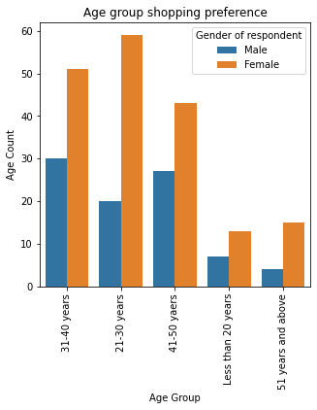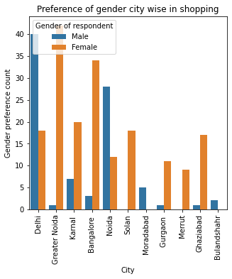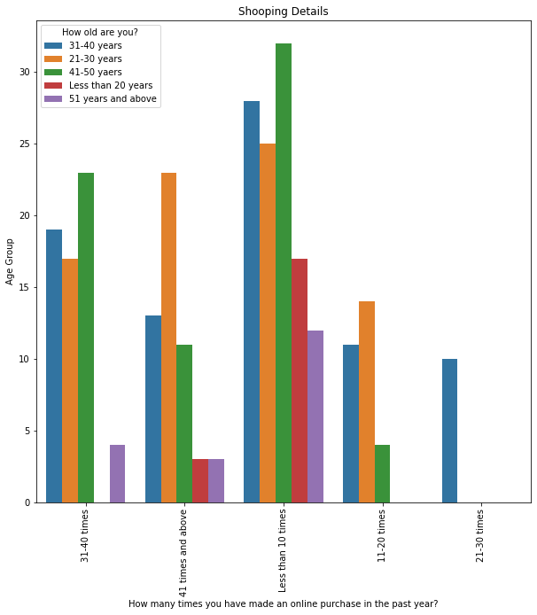

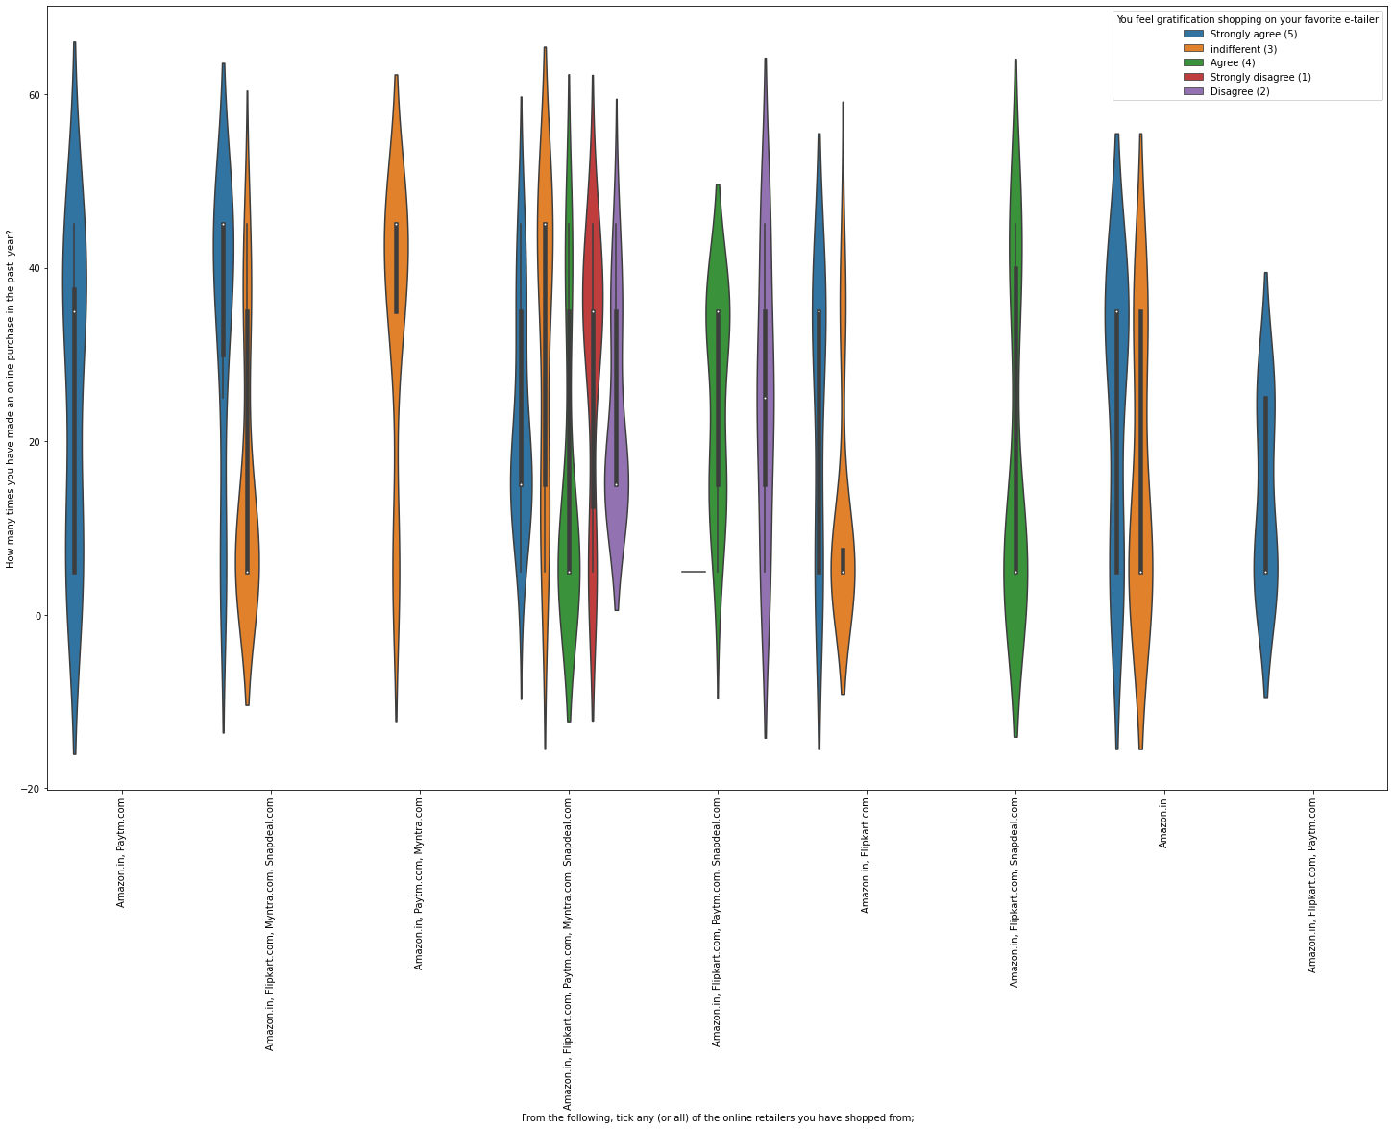

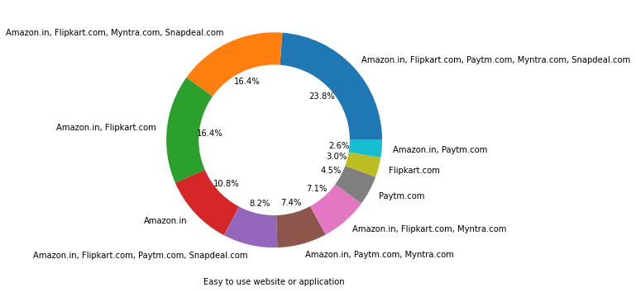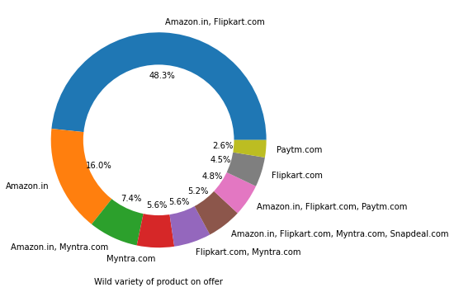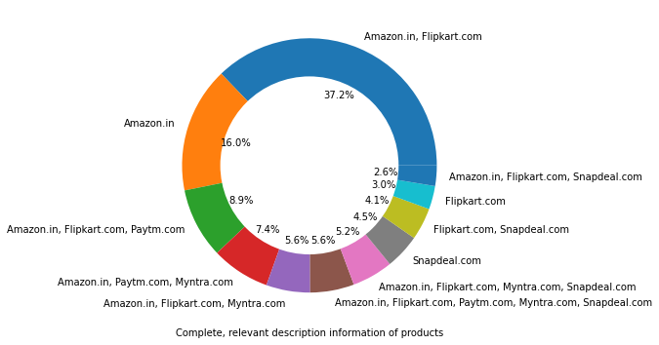

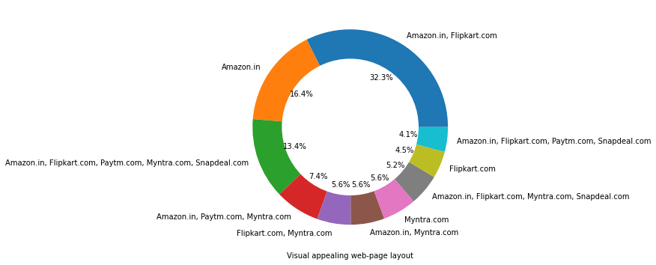

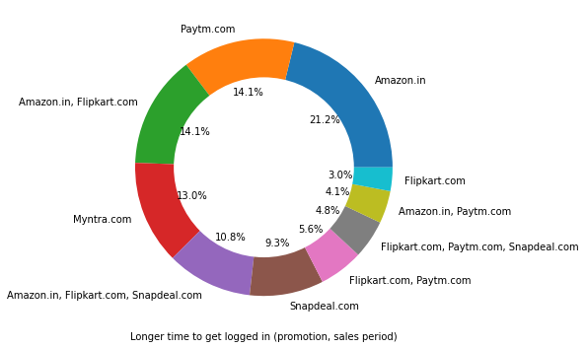

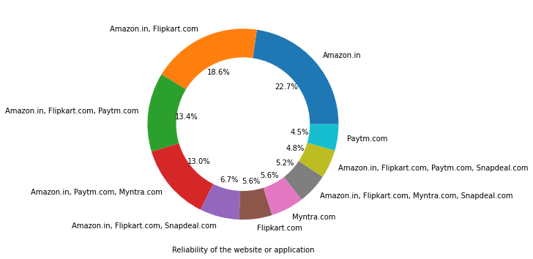

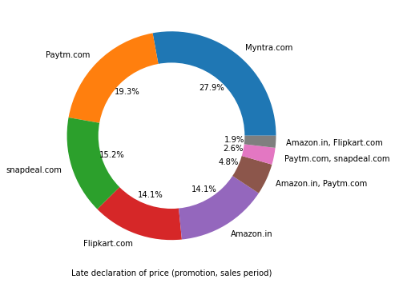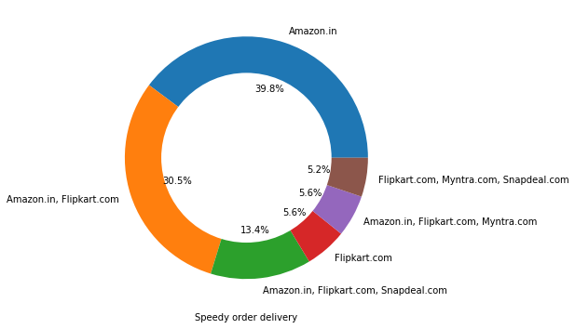

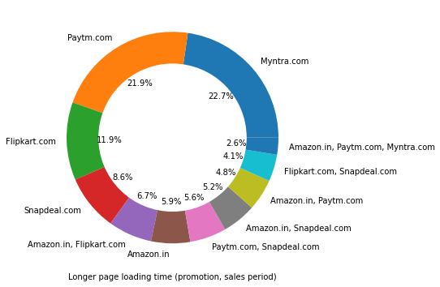

* Key Findings of the study

1. In online shopping involvement of women are more in comparison to men.
2. The age group of 31-40 is involved more in online shopping in comparision of other age group. The female belong to age group of 21-30 prefer more to shopping while men age group of 31-40 prefer to shopping.
3. Men from Delhi and Women Greater Noida prefer shopping. So we can say that shopping sites get more business from these locations.
4. mostly people from all age group has done shopping less than 10 times a year
5. We can see that Amazon and Flipkart are the most preferred brand for online shopping by customers.
6. Almost all the people who have shopped from Amazon, Flipkart and Pay-tm are satisfied. People who shop from a more number of online brands doesn’t seem to be satisfied.
7. People mostly prefer mobile internet (52.8%) followed by Wi-Fi (28%in comparison to any other medium of connectivity.
8. People use Mobile phone mostly for the shopping (52%). the least one is tablet (4.5%). Mostly buyers have 5.5 inches of mobile phones which is mostly used in online shopping. Google chrome is the mostly preferred and convenient browser than any other.
9. People come to know about their preferred shopping site through Search Engines like Google and others.
10. People from all age group prefer to spend more than 15 minutes before finalizing the product.
11. Finding better alternate is the reason which force people to abandon the product to leave the material at the shopping cart
12. Amazon.com and flipkart.com is the most preferred shopping website among the customers.
13. Amazon.in is most convenient to use for shopping followed by flipkart.com.
14. Amazon.in is the best visual appealing website for shopping followed by flipkart.com. Amazon.in has a wide variety of offers than any other website for shopping followed by flipkart.com.
15. Amazon.in provides complete information and relevant description than any other website for shopping.
16. Amazon.in is the fast loading website. Amazon.in grabs more votes in reliability section.
17. Amazon.in is very quick in terms of purchase completing convenience.
18. Amazon.in has wide variety of payment option.
19. Amazon.in is fast in delivering the customer orders, best in keeping secure the personal and financial information of customers. Seems like amazon is beating all other shopping website in the market in terms of providing the best customer experience.
20. The customer has to wait for a longer time to get logged at times promotion, sales period in Amazon.in (21.2%) followed by Paytm.com and Myntra.com.
21. Amazon.in, Myntra.com, snapdel.com has to seriously work to increase the speed of their website at the time of (promotion, sales period) to reduce the time in reflecting graphics and photos
22. Myntra.com declares their price very late during sales period/promotion. Also their Webpage takes longer time to load during sales period/promotion.
23. Snap-deal has limited number of payment modes. Snapdeal and pay-tm take long time for deliveries. Customer faces issues and disruption while moving from one page to another in Amazon.in, Snapdeal.com and Myntra.com.

* Conclusions of the Study

Below is the conclusion.

* The market is very versatile and customer is the king of the market. The online retail companies have to be more focused towards changing needs and demand of the customers, adapting changing technologies, fast networking. They need to more reliable, convenient and trust-worthy to survive and grow.
* All the websites were not equally preferred by online customers. Amazon was the most preferred followed by FLIPKART. This can be explained easily by previous result that we got. These two companies are most trusted in the industry in terms of reliability, convenience and trust worthiness, and hence, have a huge reliability. Also, the sellers listed on these websites are generally from Tier 1 cities as compared to Snap-deal and Pay-TM which have more sellers from tier 2 and 3 cities. Also, these websites have the most lenient return policies as compared to others and also the time required to process a return is low for these.